NM4225 DESIGN FICTION: HTML WORKSHOP!
- Type <!DOCTYPE html> at the top of the wordpad.

- Follow this up with <html> and </html> below it. Leave some space in between the opening and closing tags.
  - The opening <html> tag indicates that anything between it and a closing </html> tag is HTML code
  - (Note: It is good practice to type both the opening and closing tag together, so that you wont forget to close the tag later on)
- Now do the same for the <head> and </head> tags.
  - The <head> element is a container for metadata (data about data). HTML metadata is data about the HTML document and is not displayed. Metadata typically define the document title, character set, styles, links, scripts, and other meta information.
- Add <title> </title> tags within the <head> </head> tags. Think of the name you want to give to your website, and add it between the <title> tags. (Highlighted for clarity of explanation)
  - The <title> element
    - defines a title in the browser tab
    - provides a title for the page when it is added to favorites
    - displays a title for the page in search engine results
- Now moving on to the <body> </body> tags! Add the body tags AFTER the closing </head> tag.
  - Anything between the <body> </body> tags is shown inside the main browser window (i.e. this is where you put the main content of your webpage).

- From this point onwards, we will be working within the <body> tags. Anyway, headers! Use the <h1> </h1> tags to add a header at the top of your webpage
  - Remember that h1 – h6 are headers of varying sizes, with h1 being the largest and h6 being the smallest. Choose one that you think fits best!
  - Consider adding formatting elements to your header! I’ll be using <strong> in this example
    - Bold <b> </b>
    - Italics <i> </i>
    - Underline <u> </u>
    - Strikethrough <s> </s>
    - Strong <strong> </strong>

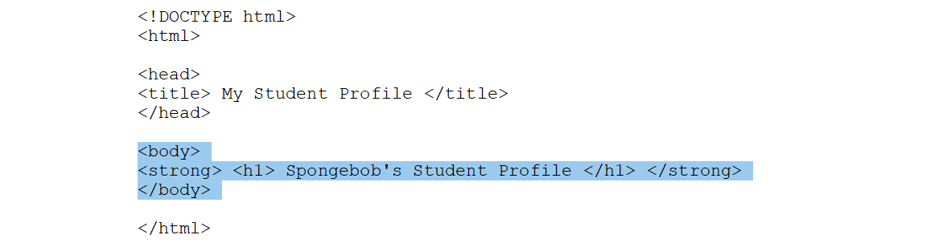

- Let’s add an image underneath your header! Add an <img src = “ “> tag underneath your header. Google up and image that you feel represents you, copy image address, and paste this within the inverted commas in your image tag.
  - In HTML the <img> tag has no closing tag.
  - If you want to use an image found in your local memory (in your computer), make sure to copy the image into your Workspace folder (same folder that contains your working html file). Then, copy the name of the image and paste it within the inverted commas.
    - E.g. <img src = “smiley.jpg”>
  - Image too large? Add a height and width formatting! Make sure it is within the img tag.
    - <img src="smiley.gif" alt="Smiley face" height="42" width="42">
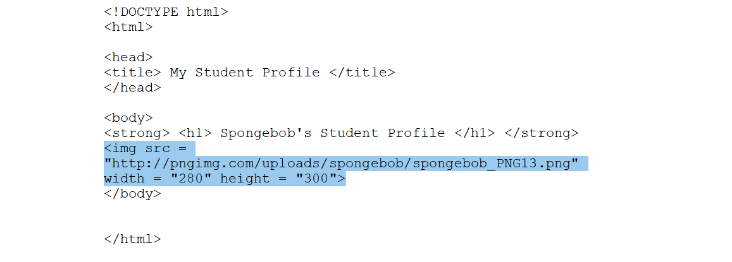
- Now lets add in your course of study underneath your image. Use a paragraph tag <p> </p> and type in your Faculty and Major.
  - Remember to use the line break tag <br> to break up the text into the next line (much like what happens when we press the ENTER key on our computers).
  - Same as earlier, add some formatting tags while you’re at it! I’ll be using the bold <b> </b> tags for this example.
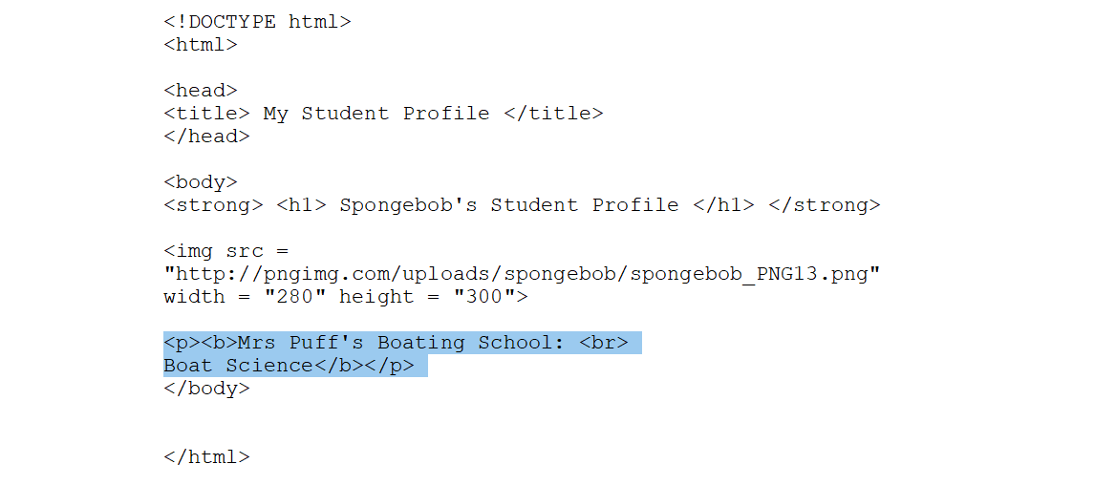
- Now for hyperlinks! Add an anchor tag <a href= “ “> </a> to the words that you want to attach a hyperlink to. Place the URL within the inverted commas, and we are good to go. I will turn my school faculty into a hyperlink, linking it up to the faculty website.
  - E.g. <p><a href= "https://www.google.com/">google</a></p>

- Let’s add another paragraph for practice. Type something about yourself! 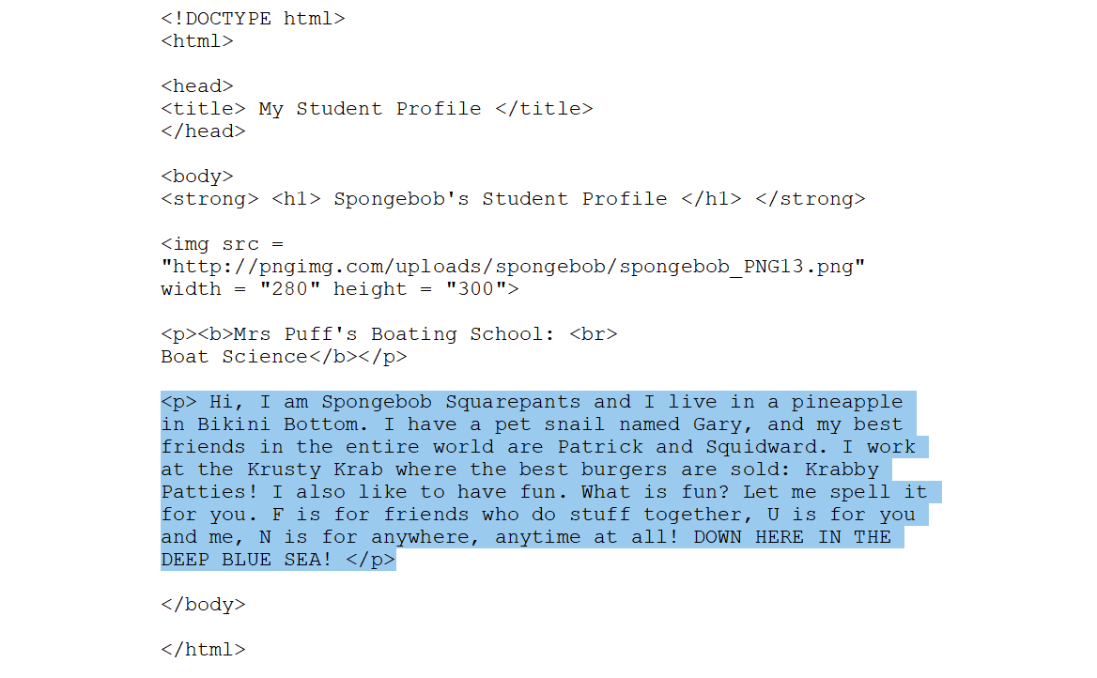
- And we are done with the main structure of your webpage! Let’s now add styling to the different parts of your website. Styles are placed inside the tags themselves and are written as such <h1 style = “color: blue”>. Try them out in different tags (paragraph, body) and see what happens!
  - Types of styling available:
    - <h1 style = "color: red"> </h1>
    - <h2 style = "font-family: Impact"> </h2>
    - <h3 style = "background-color: yellow"> </h3>
    - <h4 style = "text-shadow: 2px 2px blue"> </h4>
    - <h5 style = "font-size: 10px"> </h5>
    - <h6 style = "text-shadow: 2px 2px 10px yellow"> </h6>
  - If you want to change the background color of your page, add bgcolor="#XXXXXX" inside the <body> tag
    - E.g. <body bgcolor="#E6E6FA">
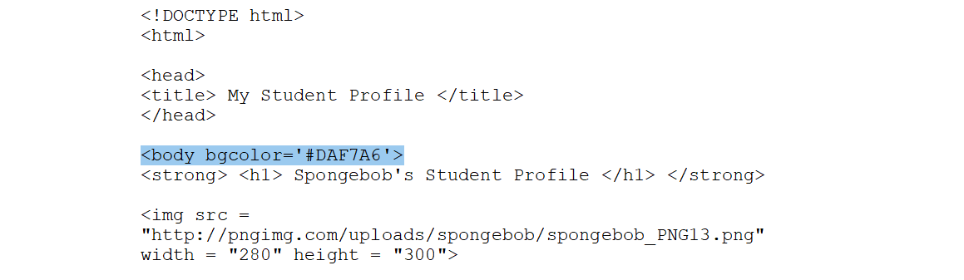
- Save your wordpad file. After saving, change the extension file from .txt to .html . Double click on the file and you’ll see your website! If you wish to edit the html file, always remember to save it first in order for your changes take effect.

